TRAVEL TALKS EDM – CONSUMER PROSPECTS

Subject line | You’re invited…
Pre-header | Join our Travel Talks for 2019
Hero banner | 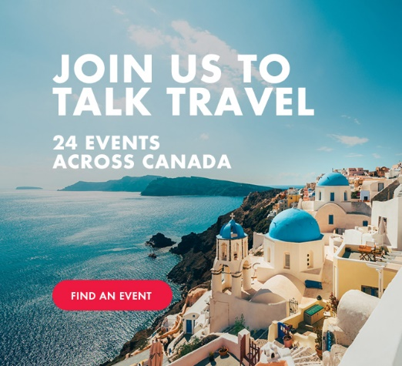 | Download the image from the website.  URL:  https://www.trafalgarevents.com/
Body copy | TRAVEL TALKS, COMING TO A CITY NEAR YOU  Get inspired by a world of destinations and have your questions answered by one of our passionate Trafalgar Experts. Take advantage of our exclusive event offers like early booking deals, gift with purchase and the chance to leave with some amazing giveaways!  Don't miss out on these exclusive savings! Space is limited, so RSVP today.  <FIND AN EVENT NEAR YOU> | Use Sapphire colour palette  https://www.trafalgarevents.com/
Footer | <<<CONSUMER FOOTER>>>

